**1. Задания 3.2.2-3.2.5. выполнить письменно**

**3.2. Word-building:**

**(-man); (-ian); (-able)**

**3.2.1.** Дайте русские эквиваленты следующих слов:

pressman, taximan, Scotsman, Congressman, jury­man, milkman, barman, policeman, railwayman, watchman, chairman, sportsman.

**3.2.2.** Ответьте на вопросы:

1. In what country do Dutchmen live?

2. Whom do we call a yes-man?

3. Do you know the meaning of the word «sand­wich-man»?

4. Is your father a party-man?

5. What does a chairman do?

6. Where does a salesman work?

7. Who is the best Russian sportsman of the year?

**3.2.3.** Закончите следующие предложения:

1. A technician is a specialist in...

2. A vegetarian is one who lives on...

3. A veterinarian is one who treats...

4. A parliamentarian is a member of...

5. An academician is a member of...

**3.2.4.** Ответьте на вопросы:

1. What do we call people who live in Bulgaria (Albania, Nigeria, Panama, California, Asia, Siberia)?

2. In what part of Europe do the Hungarians (Italians, Norwegians) live?

**3.2.5.** Перефразируйте словосочетания, используя прилагательные с суффиксом -able.

**Model**: 1. that can be prevented — preventable.

2. that can be drunk — drinkable.

that can be checked; that can be pronounced; that can be understood; that can be broken; that

can be controlled; that can be washed, that can be questioned.

**3.2.6.** Ответьте на вопросы:

1. What breakable things are there on your table?

2. Is your handwriting readable?

3. When is the weather most changeable?

4. Is it desirable for you to have two days off a week?

5. In what cases is it justifiable to miss classes?

6. Have you got a portable radio?

**2. Слова выписать и выучить**

**New words:**

floor — этаж

people's judge— народный судья.

in the suburbs— в пригороде

bathroom— ванная

kitchen — кухня

fine — *(зд.)* чудесно

in front of — перед

late — поздно

car — машина

to do the room — убирать комнату

sunny — солнечный

sleepy — сонный

at last — наконец

fridge — холодильник

besides — кроме того

to know — знать

**School vocabulary:**

to live, flat, family, parents, tomorrow, to­night, picture, to like, son, daughter, wife, dining-room, what, why, where, thing, also, to want, to be tired, long, working day, supper, to be afraid, next, to ask, to take, to answer, to give back, small, because, wall, to make, after, to see, hour, tea.

**3. Прочитайте и переведите (письменно):**

**Where do they live?**

Pete Sokolov lives in Pushkin street. He lives on the fifth floor of a new nine-storied apartment-house. His family lives in a three-room flat. There are four of them in the family. Pete's father's a worker and his mother's a people's judge. Pete's younger brother Mike is a school­boy. There are two bedrooms and a sitting-room in their flat. One bedroom is for Pete's parents, the other is for the boys. There are two beds, two chairs, a wardrobe, a desk and a lot of books in their bedroom. There is no TV-set in their room, but there's an excellent stereo system. Mike and Pete always do their room themselves. Mike often takes Pete's books and cassets and Pete gets angry. «Where are my things?» he asks or «Why do you take my books?» Mike doesn't answer anything. He gives every­thing back. But still the two brothers are good friends.

Nell Pavlova hasn't got a family and she lives alone in a small flat. She likes her flat very much. Why does she like it? Because it's so sunny and comfortable. There are many flowers in the room and a lot of photoes and pictures on the walls. Nell makes photoes herself. She likes everything in her room. But there's something she doesn't like. She doesn't like to be alone.

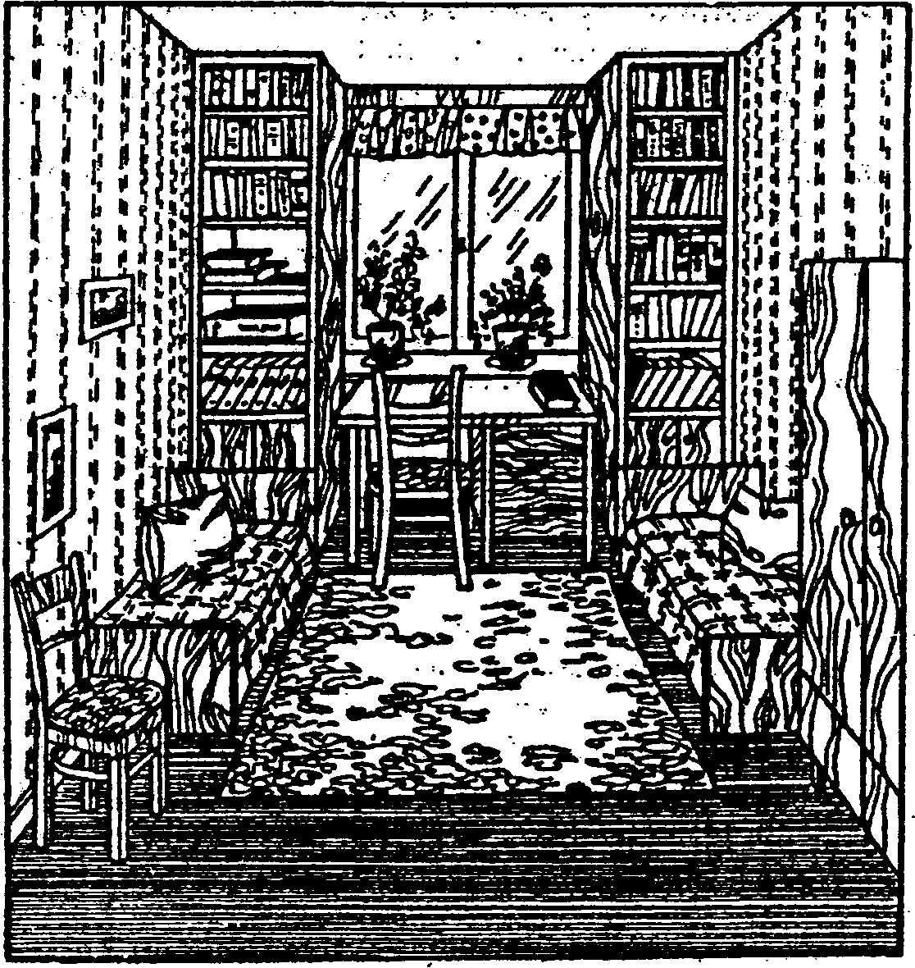

This is Steve's house. It's in the suburbs of London and Steve gets to work in his car. Still it takes him about an hour to get there.1 Steve's got a large family: a wife, two daughters and a son. There are three bed-rooms, a dining-room, a bathroom and a large kitchen in his house. There's also a little garden in front of the house. «Do you want tea or coffee?», Steve's wife asks him. But Steve wants nothing. He's very tired. He's sleepy.

I'm at home at last! It's so nice to be at home after a long working day. What's for supper to-night? Oh, I don't know myself. There's something in the fridge... Oh, there's someone on the phone!2 «2457336—two four five seven double three six»3. Jane Snow's here.4 Oh, hi John! What? Pictures? I'm afraid it's too late. Besides I don't want to go anywhere to-night. Next time, perhaps? Fine! See you tomorrow then. Bye!»

**Notes**: 1. It takes him about an hour to get there. — Ему требуется около часа, чтобы добраться туда.

2. There's someone on the phone. — Кто-то звонит.

3. Pay attention to the way the telephone number is pronounced.

4. Jane Snow's here. — Говорит Джейн Сноу.

**3.3.4.** Посмотрите, сможете ли вы найти в текстах все случаи употребления Simple Present в 3 л. ед. числа (около 20). Назовите точную цифру. Глаголы be и have (got) в счет не идут.